Why self respect is crucial for happiness?



You may think the key to happiness lies in health, wealth, and the success of your personal relationships. And all these things are key elements on the path to greater fulfilment.

But what many fail to recognize is that self-respect is crucial for happiness.

**What is self respect and why is it important?**

Self-respect means having confidence in yourself and behaving with grace, honour, and dignity.

The difference between self respect and self esteem.

Self-esteem is knowing you can conduct yourself confidently in every situation. Outwardly, you are successful, which contributes to your self-esteem. But it’s possible to experience and act with self-esteem while having little self-respect.

The problem with just relying on self-esteem, or being caught up in this evaluative framework, is the moment you have a bad day and doubt yourself, you fall prone to blame, guilt, regret, and stress.

**Difference between self respect and ego.**

Self-respect is the respect you have for yourself, while ego is your understanding of your own importance

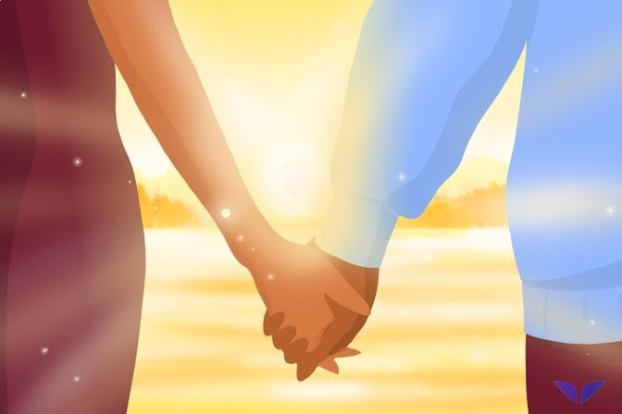

**What is self respect in a relationship?**

While it is very important to respect your partner when you are in a relationship, it is equally important to respect yourself too.

Also, self respect is the foundation of all healthy relationships.

When you accept yourself as a whole person, with both flaws and strengths, it changes how others perceive you. When you know who you are and how much you’re worth, you will not let anyone, and not even your partner, treat you as a doormat.

That is why you should practice self-respect in all of your relationships: with your partner, friends, parents, and everyone you meet.

**Why self respect is crucial for happiness?**

**1. Self-respect exhibits toughness and moral nerve.**

You will display strong character with the willingness to accept responsibility for your own life, and you’ll fight for your values and beliefs, no matter what. This will make everyone else take note and admire your courage.

**2. Self-respect makes you a better person and partner.**

If you respect yourself, you believe you’re a worthy individual. And when you feel worthy, you believe you are deserving of love and respect. And when you command respect from others around you, they’d start to appreciate you more and take you more seriously.

**3. No more need for comparisons.**

When you love yourself, you feel good, you value your attributes, your talents, your skills, and your abilities. Which means that you never compare yourself to others, and you don’t feel jealous when others shine in their own way.

**How do you show self respect?**

**1. Respect your beliefs and values.**

Determine which of your beliefs and values reflect your authentic self. Stick to them. It’s yours, and you don’t need to change them for anyone. Under no circumstances should you change your values to suit someone else, as then you will let yourself down.

2. Respect your body.

It’s the only one you have. Take care of it and pamper yourself often. Live healthily and make exercise a lifestyle priority.

3. Respect your environment.

If you can’t take care of your home or car, you can’t take care of yourself. Clean up, de-clutter and surround yourself with beautiful things that are a reflection of your beauty and character.

4. Respect your interests.

Stop hiding your hobbies. Openly share your passions. There are plenty of people who will be interested in the real you.

5. Respect your word.

The most powerful tool to have is your word. So stay honest, form opinions, openly communicate how you really feel. You owe it to yourself to speak up.

6. Respect your boundaries.

People will value you less when they realize you’re spineless and easily manipulated. Understand your limits and learn to say no.

The power of I'M ENOUGH

Always believe in yourself that you are strong enough to cope up with everything, you're perfect in your way. Never doubt yourself always remember one thing I'M ENOUGH.